Experiment-2

Aim-Fork and Commit.

What is fork?

A fork is a new repository that shares code and visibility settings with the original “upstream” repository. Forks are often used to iterate on ideas or changes before they are proposed back to the upstream repository, such as in open-source projects or when a user does not have write access to the upstream repository.

How to fork a repository in GitHub?

1)On GitHub.com, navigate to the Narcos repository.

2)In the top-right corner of the page, click **Fork.**

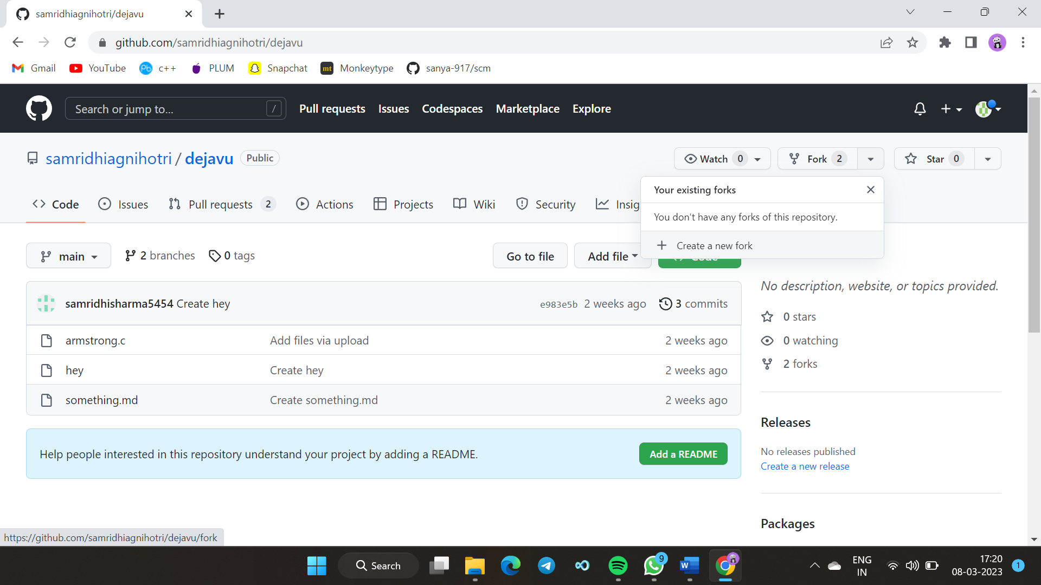

Figure 10

3) Select an owner for the forked repository.

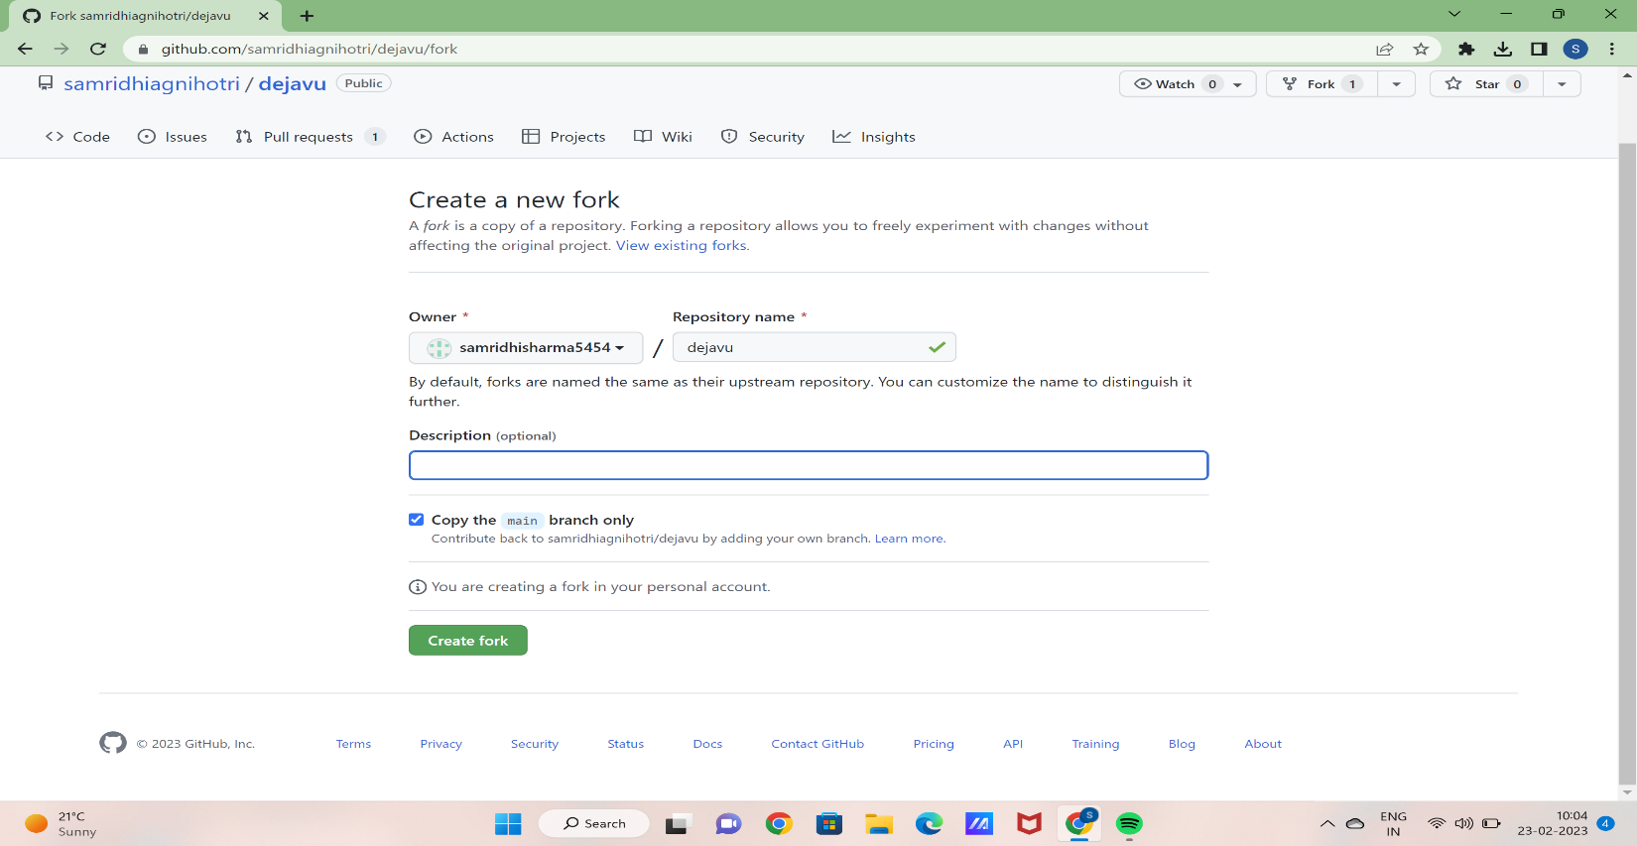

Figure 11

4) By default, forks are named the same as their upstream repositories. You can change the name of the fork to distinguish it further.

5) Optionally, add a description of your fork.

6) Choose whether to copy only the default branch or all branches to the new fork. For many forking scenarios, such as contributing to open-source projects, you only need to copy the default branch. By default, only the default branch is copied.

7)Click **Create fork.**

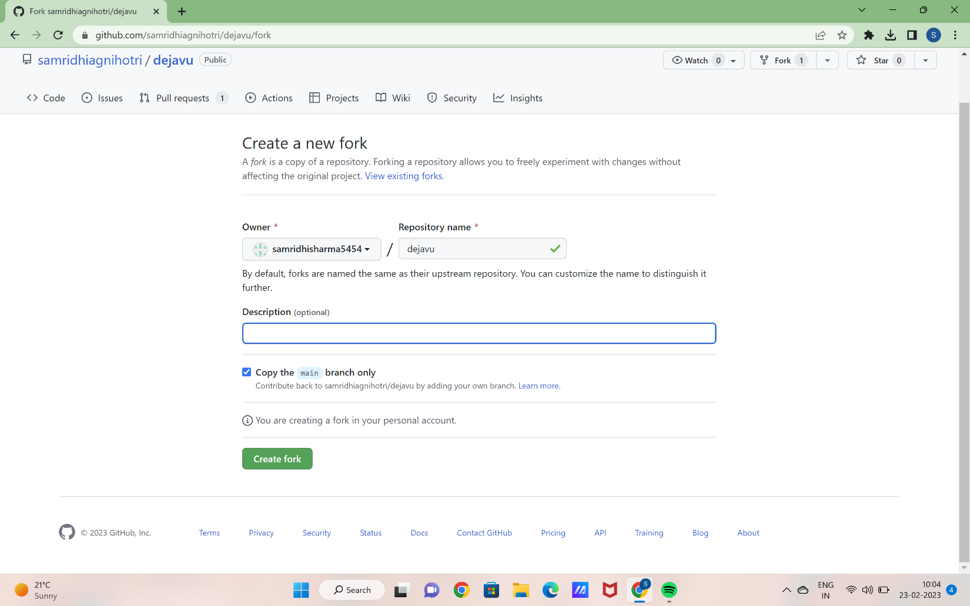

Figure 12

**Commit and creating a pull up request**

1)switch to the repository in which you want to add changes and made some changes.

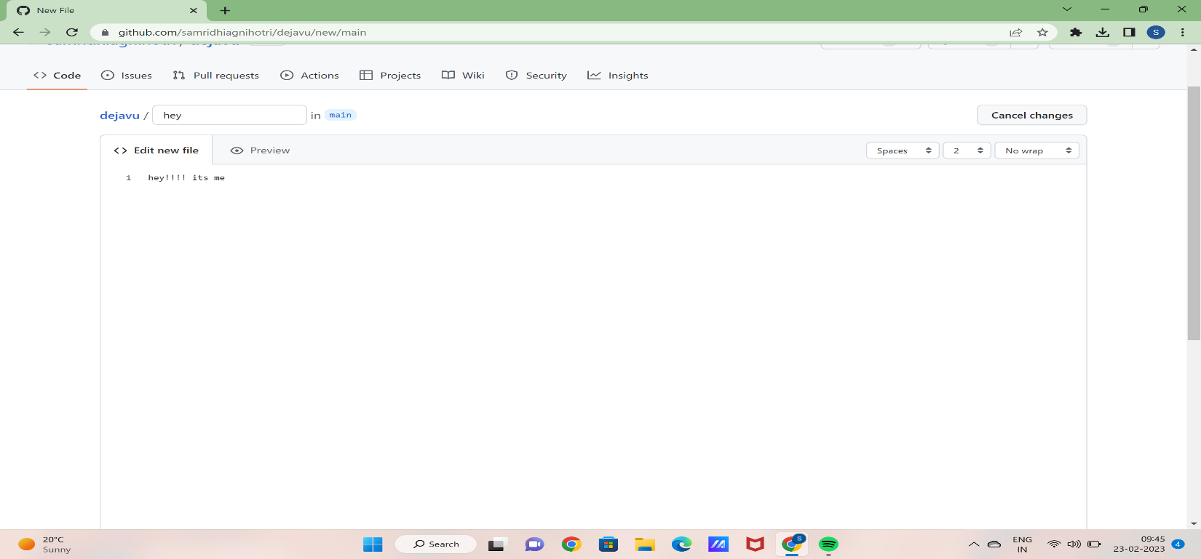

Figure 13

2)Add the description before committing.

3)If you want to commit directly to the main branch then click on commit directly else click on creating a pull up request.

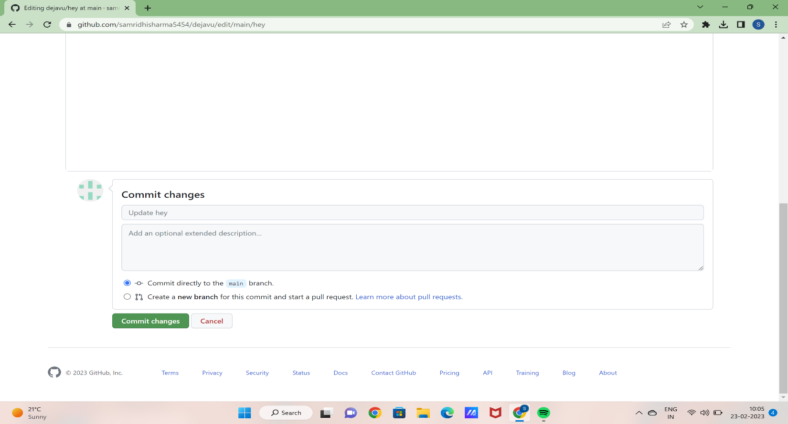

Figure 14

4)Changes have been committed successfully.

**Creating a pull request**

1)Switch to the branch that you want to create a pull request for.

2)Click **Create Pull Request**. GitHub Desktop will open your default browser to take you to GitHub.

3)On GitHub, confirm that the branch in the **base**drop-down menu is the branch where you want to merge your changes. Confirm that the branch in the **compare** drop-down menu is the topic branch where you made your changes.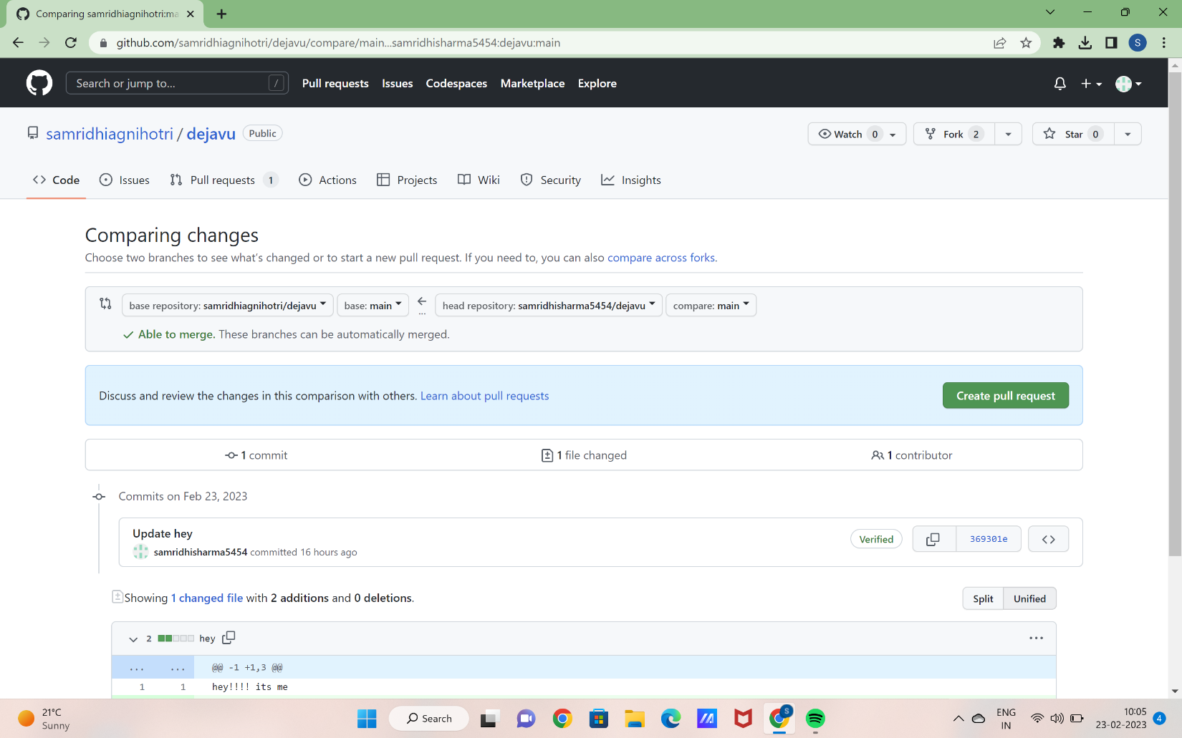

Figure 15

4) Type a title and description for your pull request.

5) To create a pull request that is ready for review, click **Create Pull Request**. To create a draft pull request, use the drop-down and select **Create Draft Pull Request**, then click **Draft Pull Request**. For more information about draft pull requests.

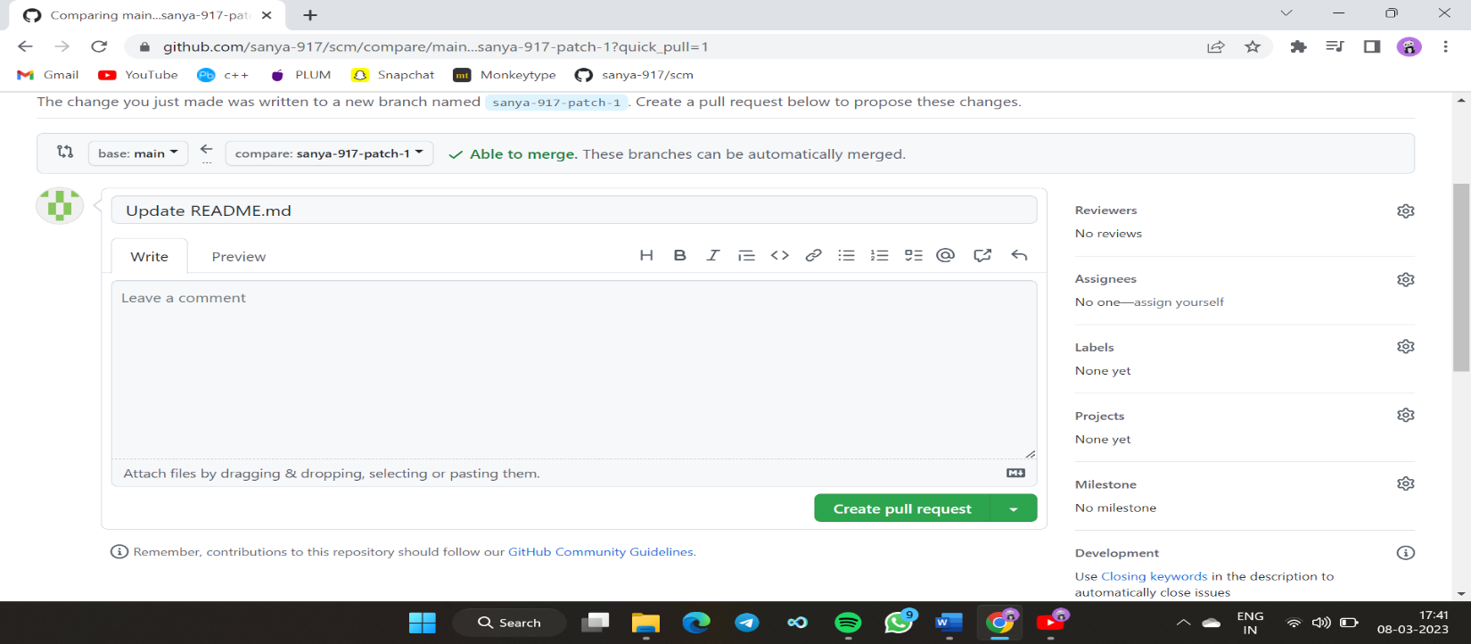

Figure 16

Experiment-3

Aim: Merge and Resolve conflicts created due to own activity and collaborators activity.

Version control systems are all about managing contributions between multiple distributed authors (usually developers). Sometimes multiple developers may try to edit the same content. If Developer A tries to edit code that Developer B is editing a conflict may occur.

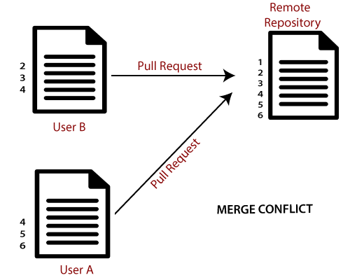

If you have a merge conflict on the command line, you cannot push your local changes to GitHub until you resolve the merge conflict locally on your computer.

To alleviate the occurrence of conflicts developers will work in separate isolated branches. If a merge conflict still arises between the compare branch and base branch in your pull request, you can view a list of the files with conflicting changes above the Merge pull request button. The Merge pull request button is deactivated until you've resolved all conflicts between the compare branch and base branch.